

___________________________________________________________

**SCHOOL OF ENGINEERING AND TECHNOLOGY**

**FINAL ASSESSMENT FOR THE BSC (HONS) INFORMATION TECHNOLOGY; BSC (HONS) COMPUTER SCIENCE; BACHELOR of SOFTWARE ENGINEERING (HONS)YEAR 2**

**ACADEMIC SESSION 2023; SEMESTER 3**

**PRG2104: OBJECT ORIENTED PROGRAMMING**

**Project DEADLINE: Week 14**

**INSTRUCTIONS TO CANDIDATES**

# 

# This assignment will contribute 50% to your final grade.

* This is an individual assignment.

**IMPORTANT**

# The University requires students to adhere to submission deadlines for any form of assessment. Penalties are applied in relation to unauthorized late submission of work.

# Coursework submitted after the deadline will be awarded 0 marks

**Lecturer’s Remark** (Use additional sheet if required)

I.............................. (Name) ...................std. ID received the assignment and read the comments....................................... (Signature/date)

**Academic Honesty Acknowledgement**

“I Tee Meng Kiat (student name). verify that this paper contains entirely my own work. I have not consulted with any outside person or materials other than what was specified (an interviewee, for example) in the assignment or the syllabus requirements. Further, I have not copied or inadvertently copied ideas, sentences, or paragraphs from another student. I realize the penalties *(refer to page 16, 5.5, Appendix 2, page 44 of the student handbook diploma and undergraduate programme)* for any kind of copying or collaboration on any assignment.”

(20/8/2023

….................................. (Student’s signature / Date)

Table of Contents

1.0 Introduction 1

2.0 UML Diagram 7

3.0 Game Features 10

3.1 Game User Interface 10

3.2: User Navigation and Shooting (Mouse and Keyboard input) 16

3.3 Enemy Movement (Chasing Enemy and normal enemy) 18

3.4 Collision detection (Player collision between walls, enemy, and bonus) 21

3.5 Collision detection (Enemy collision between walls, and Ammo (bullet) 23

3.6 Sprite Image 24

4.0 Strengths and weaknesses 25

4.1 Strengths 25

4.2 Weaknesses 26

5.0 Personal Reflection 26

5.1 OOP Concept 26

5.2 Challenges 28

6.0 Conclusion 30

7.0 References 31

# 1.0 Introduction

Video Presentation for Top Down Shooter Game: <https://youtu.be/j_0r3NggiA8>

Google Drive link: <https://drive.google.com/file/d/1t9k-f6B5n-Q8QCsZVGH3l8oE778AzkGJ/view?usp=sharing>

Object-Oriented Programming (OOP) is a programming paradigm that structures applications using objects, which contain both data and methods. This approach promotes code reusability, scalability, and maintainability, forming the architectural backbone of many modern games. Among the languages that embody OOP principles is Scala, a high-level programming language renowned for its concise syntax and the seamless integration of both functional and object-oriented programming features. Its flexibility and robustness make Scala an ideal platform for intricate and efficient game designs. In this project, Scala's capabilities and the principles of Object-Oriented Programming is utilized to develop a top-down shooter game. This combination allowed us to create a user-friendly and engaging gaming experience that showcases the elegance and effectiveness of modern programming techniques.

In this top down shooter game, Model-View-Controller (MVC) pattern is used as a architectural pattern to develop our game project, as it aligns well with Object-Oriented Programming (OOP) concepts. It separates the application into three interconnected components, aiming to isolate the game logic, user interface, and user input, making the system more modular and easier to manage.

Model: The Model represents the core logic and data of the application. In our shooter game, it defines the structure of the game object (Includes Ammo, Chasing Enemy, Enemy, Bonus) and the rules to manipulate that game object. In the context of OOP, the Model consists of classes that encapsulate the attributes and methods related to the game logic. It's responsible for adding in the new enemy/ bonus/ increase ammo and notifying the View of changes to that object.

View: The View is concerned with how the data is presented to the user. It defines the layout and appearance of the user interface. In OOP, the View can be implemented as a collection of objects that render the data from the Model. These objects can be instantiated and manipulated to change the appearance of the application without altering the underlying logic or data structure. In our game, it consists of few different interface such as the Menu Page, Game Instruction Page, Game Interface and Game Over.

Controller: The Controller acts as a mediator between the Model and the View, handling user input and translating it into commands for the Model or View. In OOP terms, the Controller is composed of methods and attributes that define how user interactions are handled. It takes the user's input, processes it (often with the help of methods defined in the Model), and returns the output display to the View. There are at least one controller for each our interface, which allow player to navigate to the next page and allow play keyboard and mouse input to play the game.

The MVC pattern leverages the principles of OOP, such as encapsulation, abstraction, and modularity, to create a well-organized codebase. By separating the concerns into distinct classes and objects, we can create more maintainable, scalable, and testable code. Each component (Model, View, Controller) can be developed, tested, and modified independently if changes are needed in the game, yet they work together cohesively to provide a seamless user experience. This alignment with OOP concepts makes MVC a popular choice for building robust and flexible applications.

To understand our Top Down Shooter game, it is a genre of video game where the player views the action from above and controls a character that shoots enemies and avoids obstacles.

**Game View:**

The game is a 2D game where the player is able to view from the top to down perspective, which give an overview of the battlefield. Figure 1.1 shows the game interface for the top down shooter game.

*\*\*Note that all the design, including background are* ***self designed*** *using Canva*

**Self-designed material link:**

1. *SpriteSheet:* [*https://www.canva.com/design/DAFsEdevgqA/wVqLwM9SrrcNsX34cqGeSw/edit?utm_content=DAFsEdevgqA&utm_campaign=designshare&utm_medium=link2&utm_source=sharebutton*](https://www.canva.com/design/DAFsEdevgqA/wVqLwM9SrrcNsX34cqGeSw/edit?utm_content=DAFsEdevgqA&utm_campaign=designshare&utm_medium=link2&utm_source=sharebutton)
2. *Background:* [*https://www.canva.com/design/DAFqFL6HYcQ/x1evjGN8Dzv_rcBnP-_VGA/edit?utm_content=DAFqFL6HYcQ&utm_campaign=designshare&utm_medium=link2&utm_source=sharebutton*](https://www.canva.com/design/DAFqFL6HYcQ/x1evjGN8Dzv_rcBnP-_VGA/edit?utm_content=DAFqFL6HYcQ&utm_campaign=designshare&utm_medium=link2&utm_source=sharebutton)

Figure 1.1:

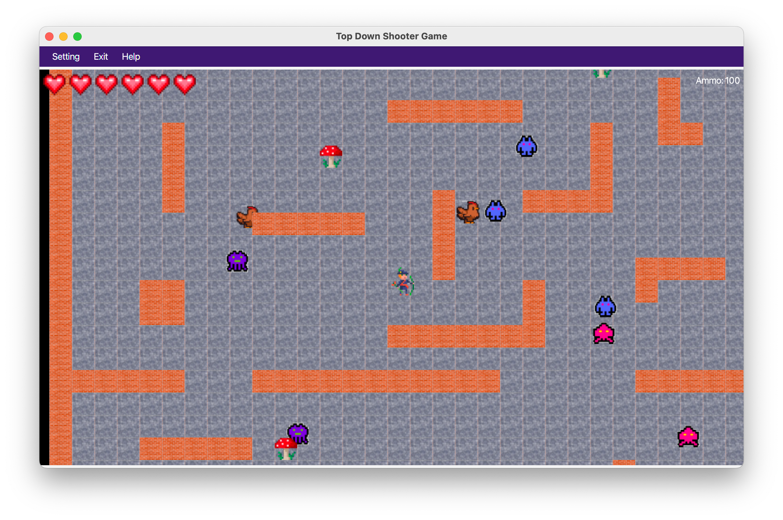

**Game Characters:**

Figure 1.2

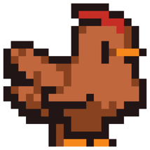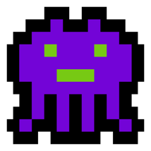

These are the enemy generated during the running of the game. Figure 1.2 represent the faces of enemy will be generated in the game. The player need to shoot down and clear all the enemy.

The chicken enemy, represent by the last picture, is the enemy that will trace the player and follow the player. It only have 3 chicken enemy in the whole game.

Figure 1.3:

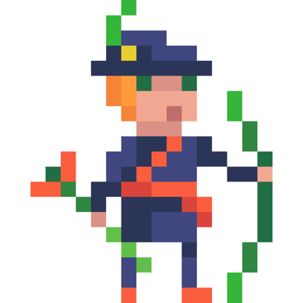Shooter: This is the shooter where the player have in control over.

The shooter have total of 6 hearts. When all the hearts disappears, the game is over. (Number of hearts shows on the top left of screen).

The shooter have 100 ammo, which can use to shoot the enemy. (Number of ammo shows on the top right of screen).

Figure 1.4:

There are bonus point where the shooter can collect. The bonus point might help the shooter increase its health or increase it bullet by 10. The player would not be able to know which content is inside the bonus point

**Game Control:**

In our shooter game, we can control the player movement by using the keyboard, we can use either keys W A S D or keys Up Down Left Right.

To shoot bullet, we can click by simply using the mouse pad. The bullet will shot toward the direction of mouse where its being clicked.

# 2.0 UML Diagram

Figure 2.1 Overview of the UML class Diagram:

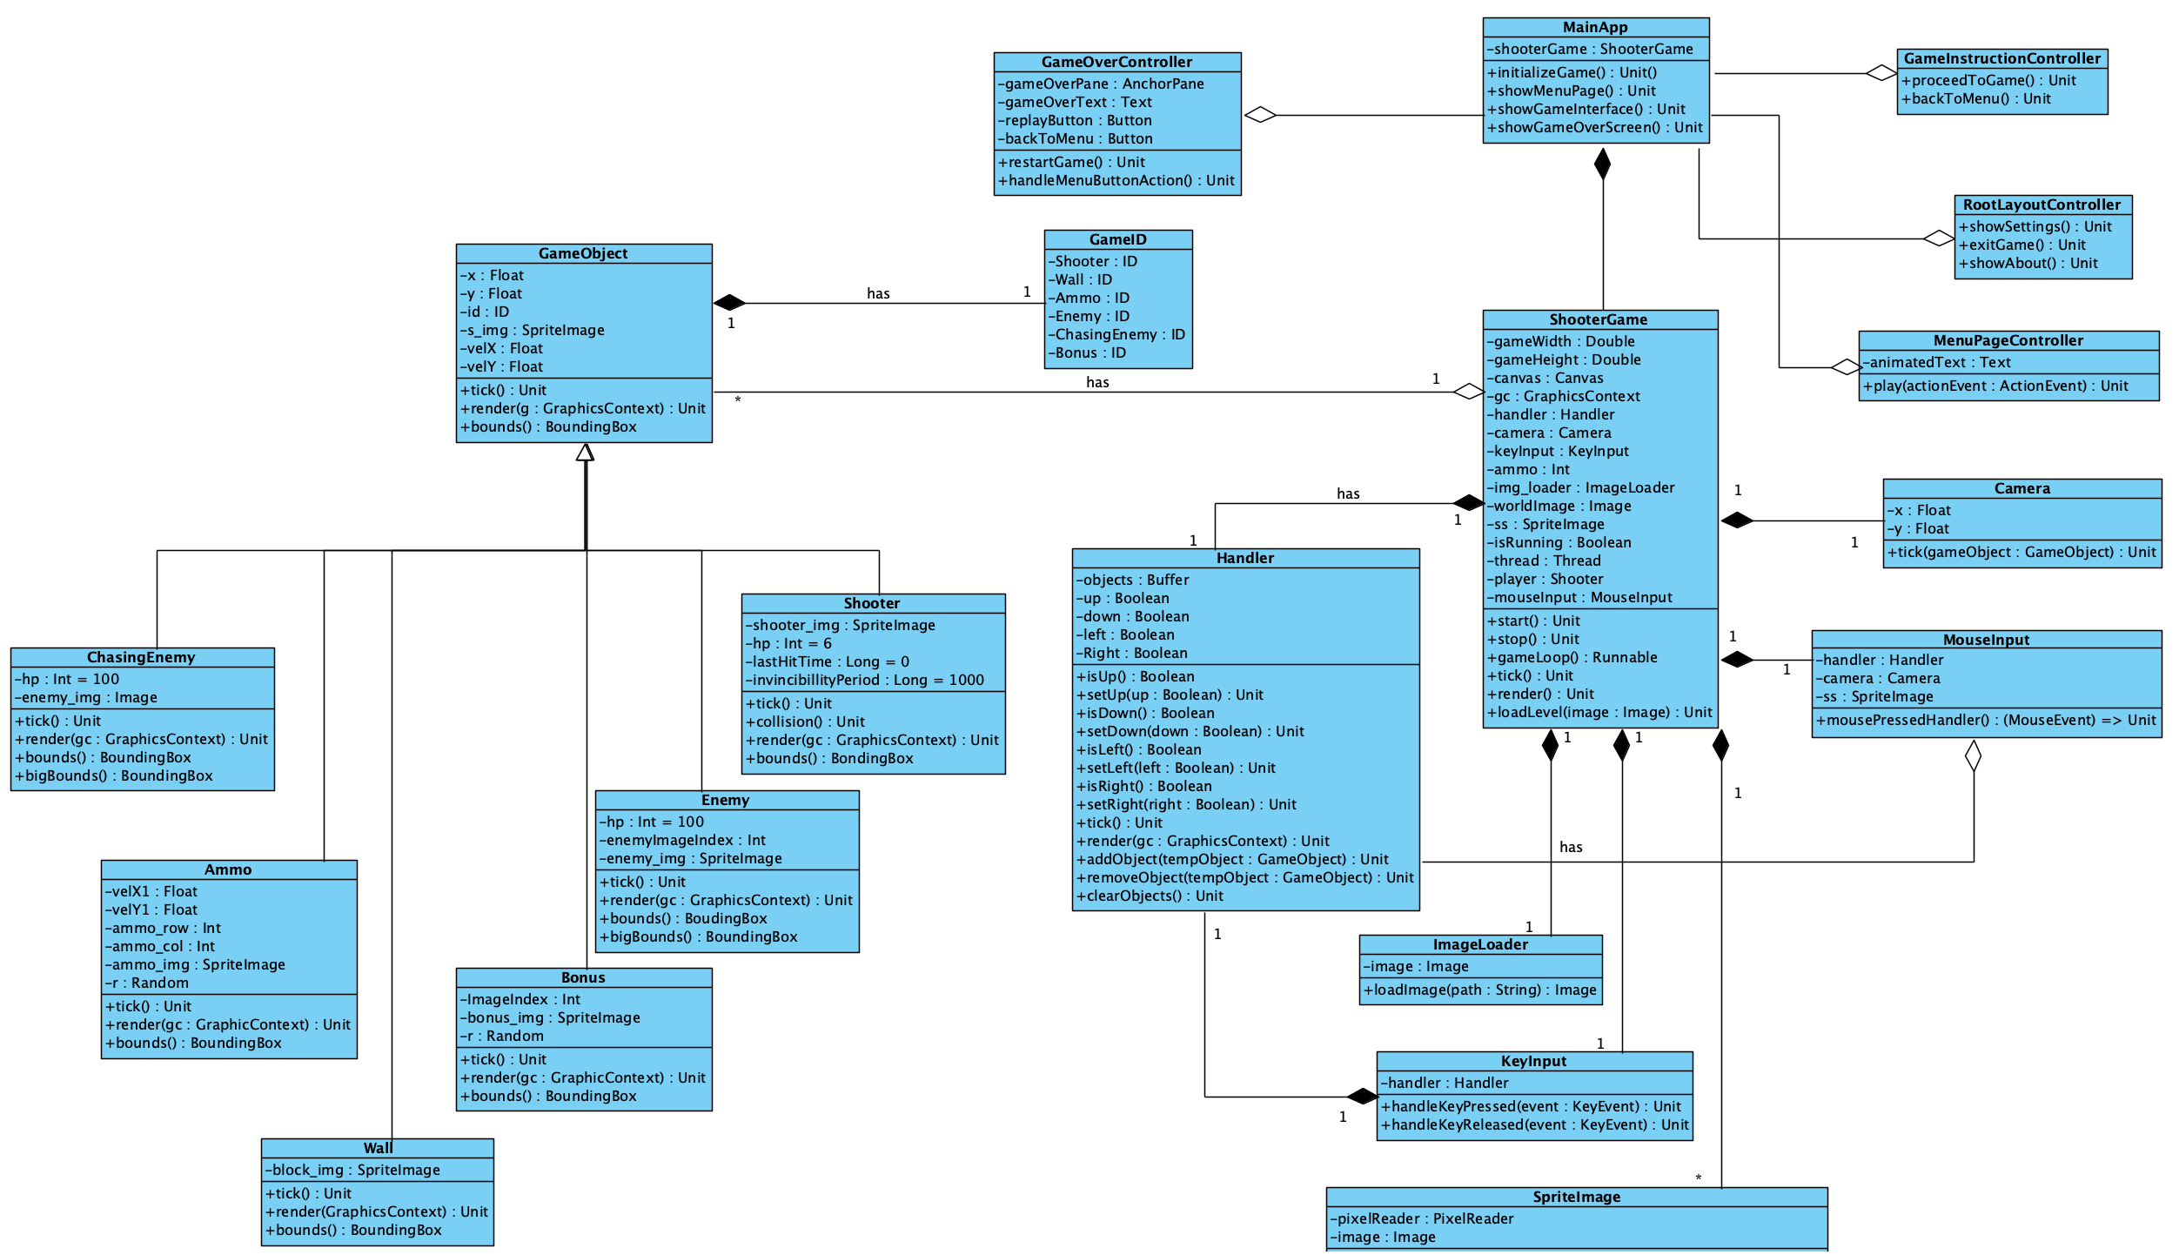

Figure 2.1 shows the overview of the classes and their relationship. Inheritance, composition and aggregation present in our Top Down Shooter game project.

Figure 2.2 Zoomed in Left portion:

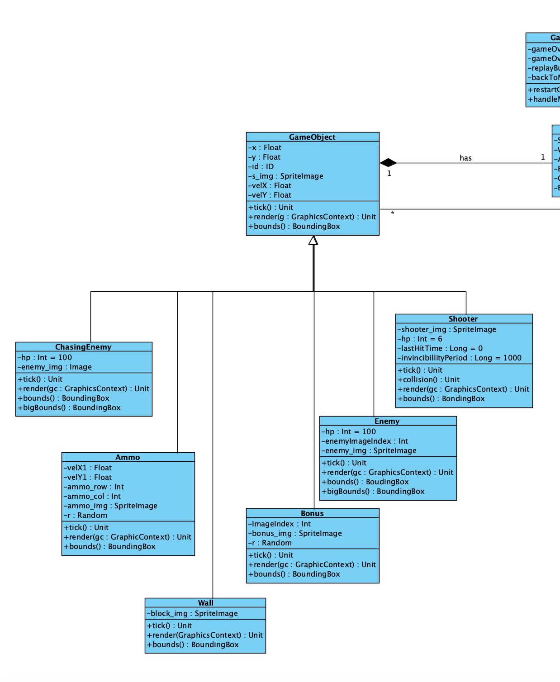

The left part of the UML diagram shows all the necessary game objects. An abstract class of GameObject is created, the Shooter, Enemy, Bonus, Wall, Ammo and ChasingEnemy all inherited from the abstract class GameObject. In most of the sub classes, it override the methods inside the superclass to provide specific functionality. For example tick method to update the states of each game object and the render method to draw out the necessary part shows on screen.

Figure 2.3 Zoomed In Right portion:

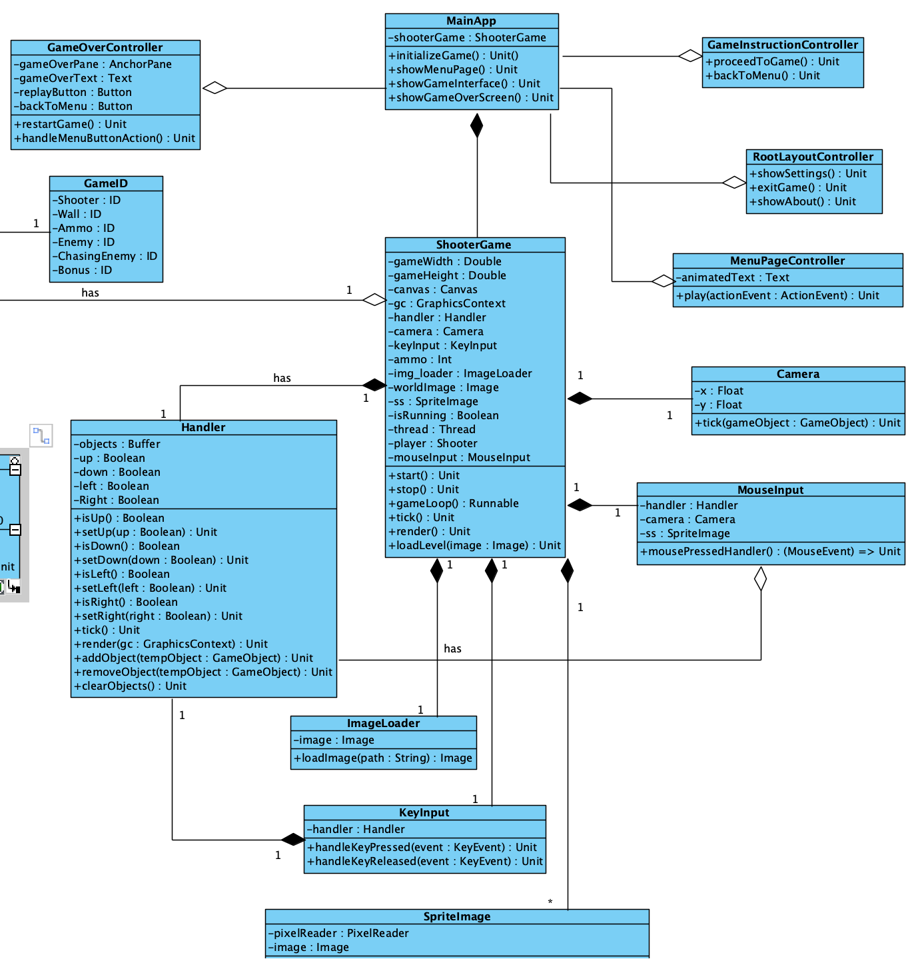

In the right portion of the class diagram, the game's model components are represented, which play crucial roles in game execution and input handling. Classes such as MouseInput and KeyInput are responsible for managing user interactions. The ShooterGame class, in particular, encapsulates all the core logic required to run the Top Down Shooter game. It also called and creates instances from all the necessary classes that are needed for game execution.

In the MainApp class, the game interface is created, including the Menu Page, Game Instruction page, Gaming Interface and Game Over interface. The initialization of the game, start at the Main App and it creates an instance of the ShooterGame to run the game and show on screen.

# 3.0 Game Features

## 3.1 Game User Interface

In our Top Down shooter Game, it consists of 4 main user interface that allow the user to interact with. (Menu Page, Game Instruction Page, Game Interface, Game Over Page).

Figure 3.1.1:

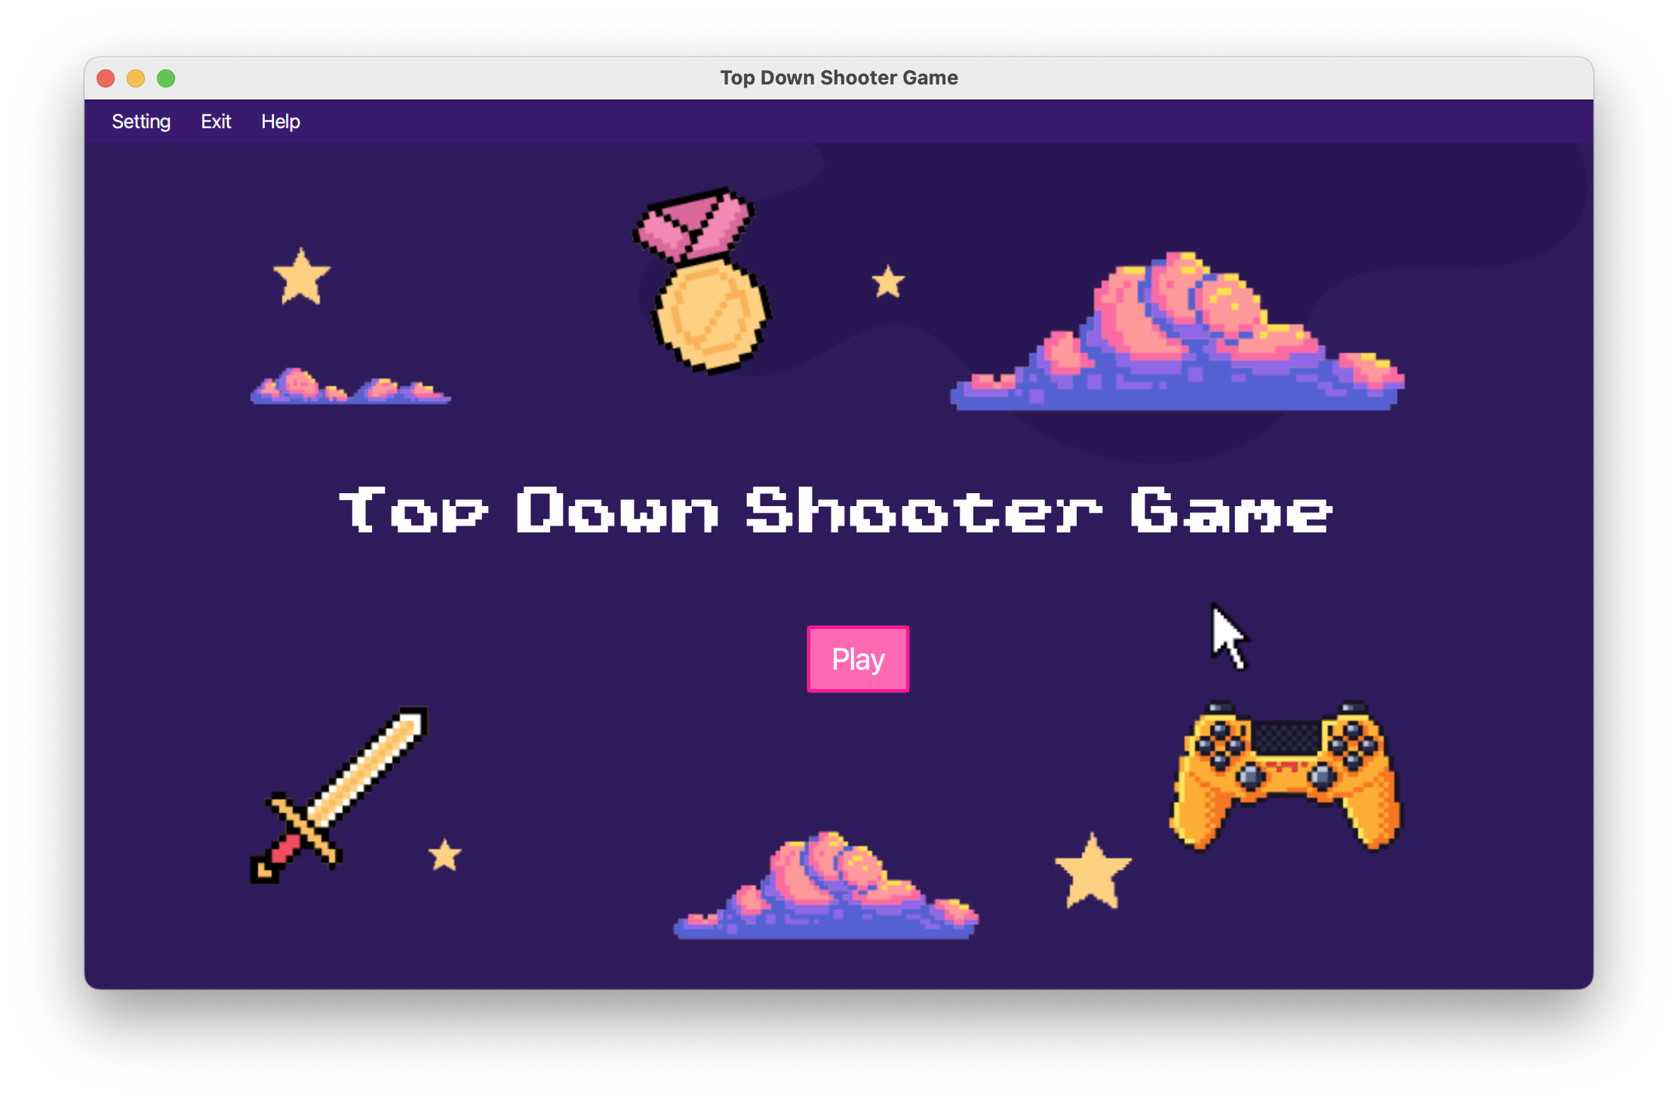

The Menu page consists of 1 button that allow the user to play the game. The upper part consists of the Menu Bar, which allow the user to interact with and quit the game if needed.

Figure 3.1.2 Help> About:

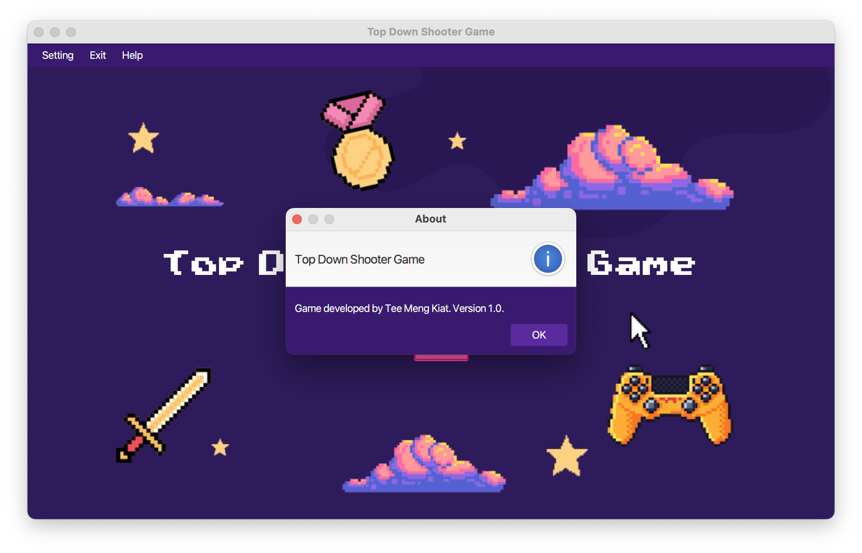

In figure 3.2.1, it prompt out the message by create an instances of Alert object. If the exit button on the menu page is triggered, it will quit the game interface.

The styling of the Menu Bar, Play Button is done by using **styles.css** file. Which allow the text and button to be style in different colour.

In the Menu Page, it is shown by creating a primary scene in the **MainApp**. The **MenuPage.fxml** file is being loaded and shown on screen. When the button play is clicked, the **MenuPageController** will handle the function by navigate the user into the next interface.

Figure 3.1.3 Play button clicked on the Menu page:

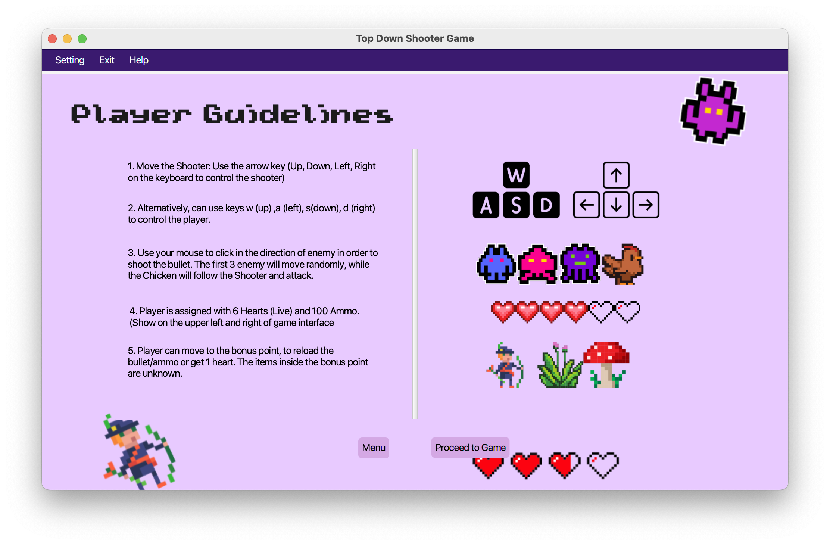

Before playing the game it will prompt the instruction, the **GameInstruction.fxml** is loaded on to the primary scene and display on the screen, and the **GameInstructionController** class will handle upon the button is triggered. The player can navigate back to the menu page and proceed to the game.

Figure 3.1.4:

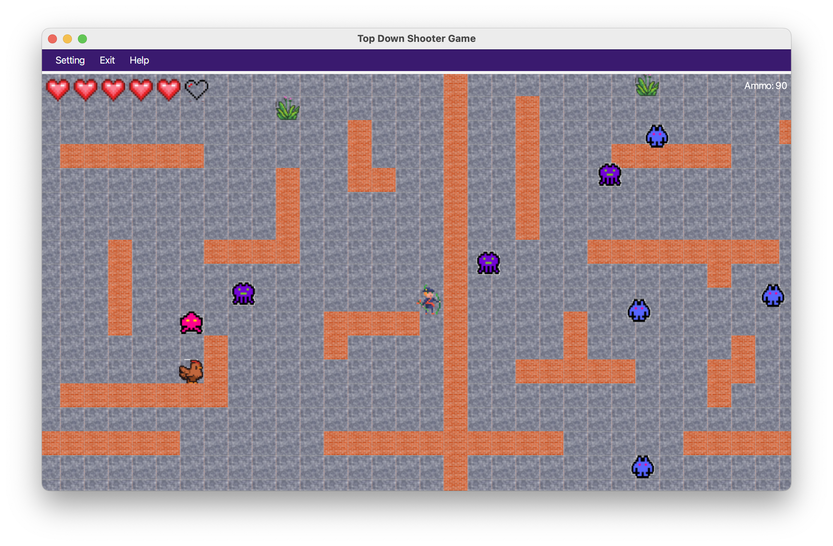

In the game interface, the scene is loaded to the primary scene. The **MainApp** will create an instance of **ShooterGame** to run the game logic. Inside the game logic, it consists of multiple important function.

gameLoop:

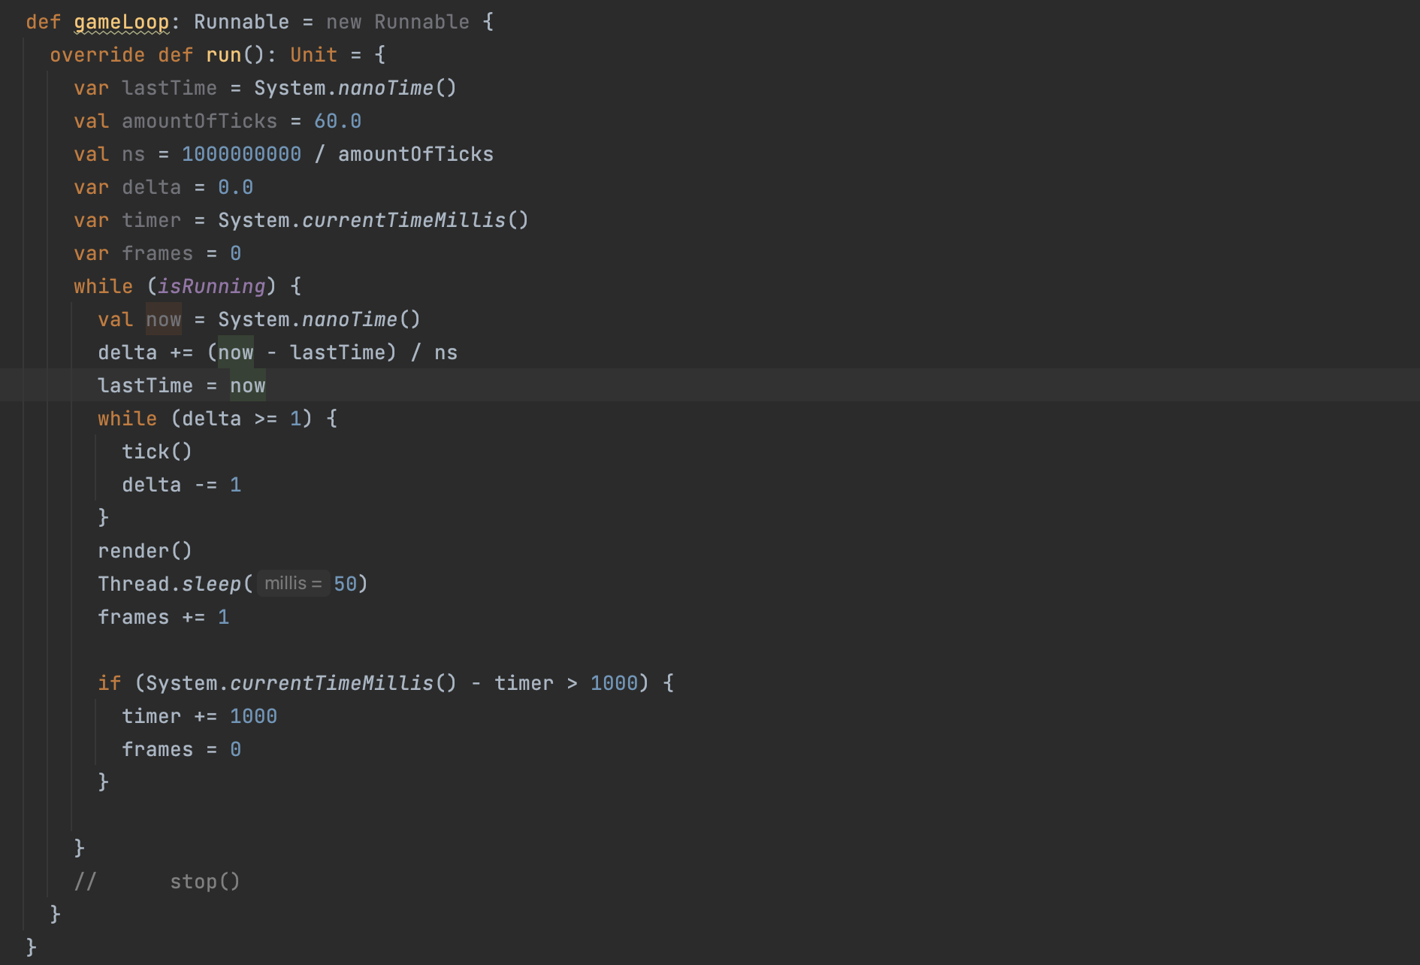

The **ShooterGame** class's game loop controls the game's flow and makes sure that updates and rendering happen consistently at the desired pace of 60 times per second. The loop begins by setting up variables to control timing, then moves into a cycle where it counts down the amount of time since the last update, calls the **tick()** function to update the game state, and then calls the **render()** method to display the current state on the screen. A sleep mechanism and a frames counter are also incorporated into the loop for pace management and prospective performance monitoring, respectively. The core of the game is this constant updating and rendering cycle, which makes for a fluid and dynamic gameplay that responds to player’s choices and actions.

render():  
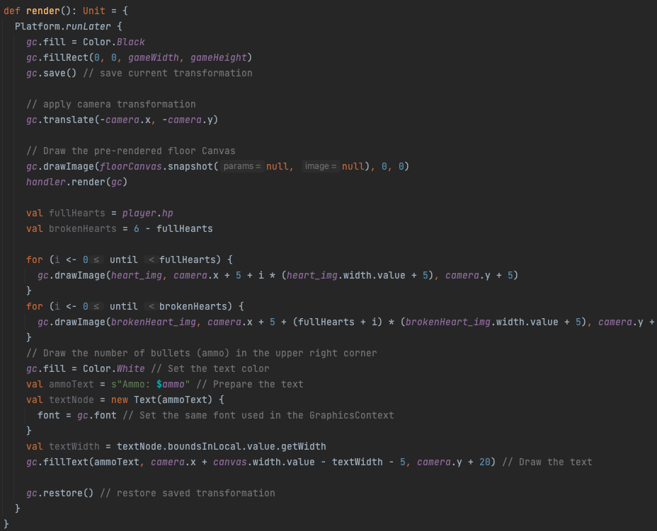

The **ShooterGame** class's **render()** function is in charge of graphically displaying the game's current state on the screen. The previous frame with a black backdrop is first erased, after which the current transformation state is saved. It creates the pre-rendered floor canvas and applies a camera transformation to view the game world from the appropriate angle. The **handler.render(gc)** call renders the game objects, and other components like player health (maximum of 6 full hearts, drawn based on the number of health the player have) and ammunition are drawn on top of it. Following that, the method restores the previously saved transformation to make sure that subsequent rendering processes begin in a fresh condition. The **render()** function updates the graphics in this way to bring the game's logic and data to life and provide the user a real-time visual depiction of the game play.

loadLevel():

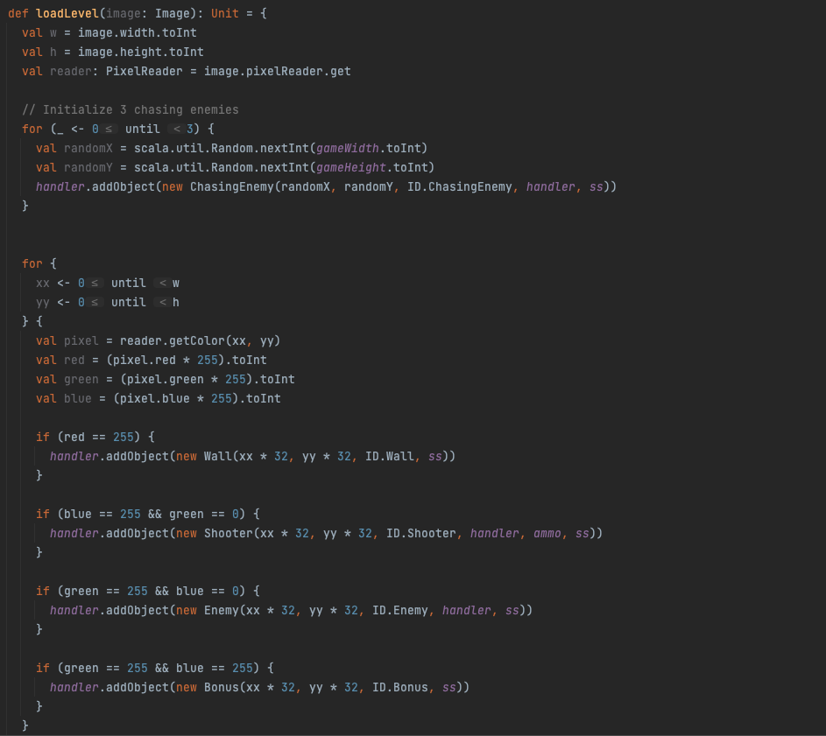

Initialising the basic interface of the game based on an input image is the responsibility of the **loadLevel** function in the **ShooterGame** class. To arrange different game elements like walls, adversaries, and bonuses at appropriate locations in the game area, it analyses the pixels of the image and interprets various colour values. For instance, a red pixel (RGB, R= 255) might represent a wall, and other colour of green (G=255) and blue tones (B = 255) might represent enemy and shooter. In order to convert the colour information into game objects and add them to the handler, the function iterates through the full image. Furthermore, it initialises 3 number of chasing enemy in random places. This strategy gives the game a flexible way to develop and load levels by converting a visual map into an interactive one.

Figure 3.1.5:

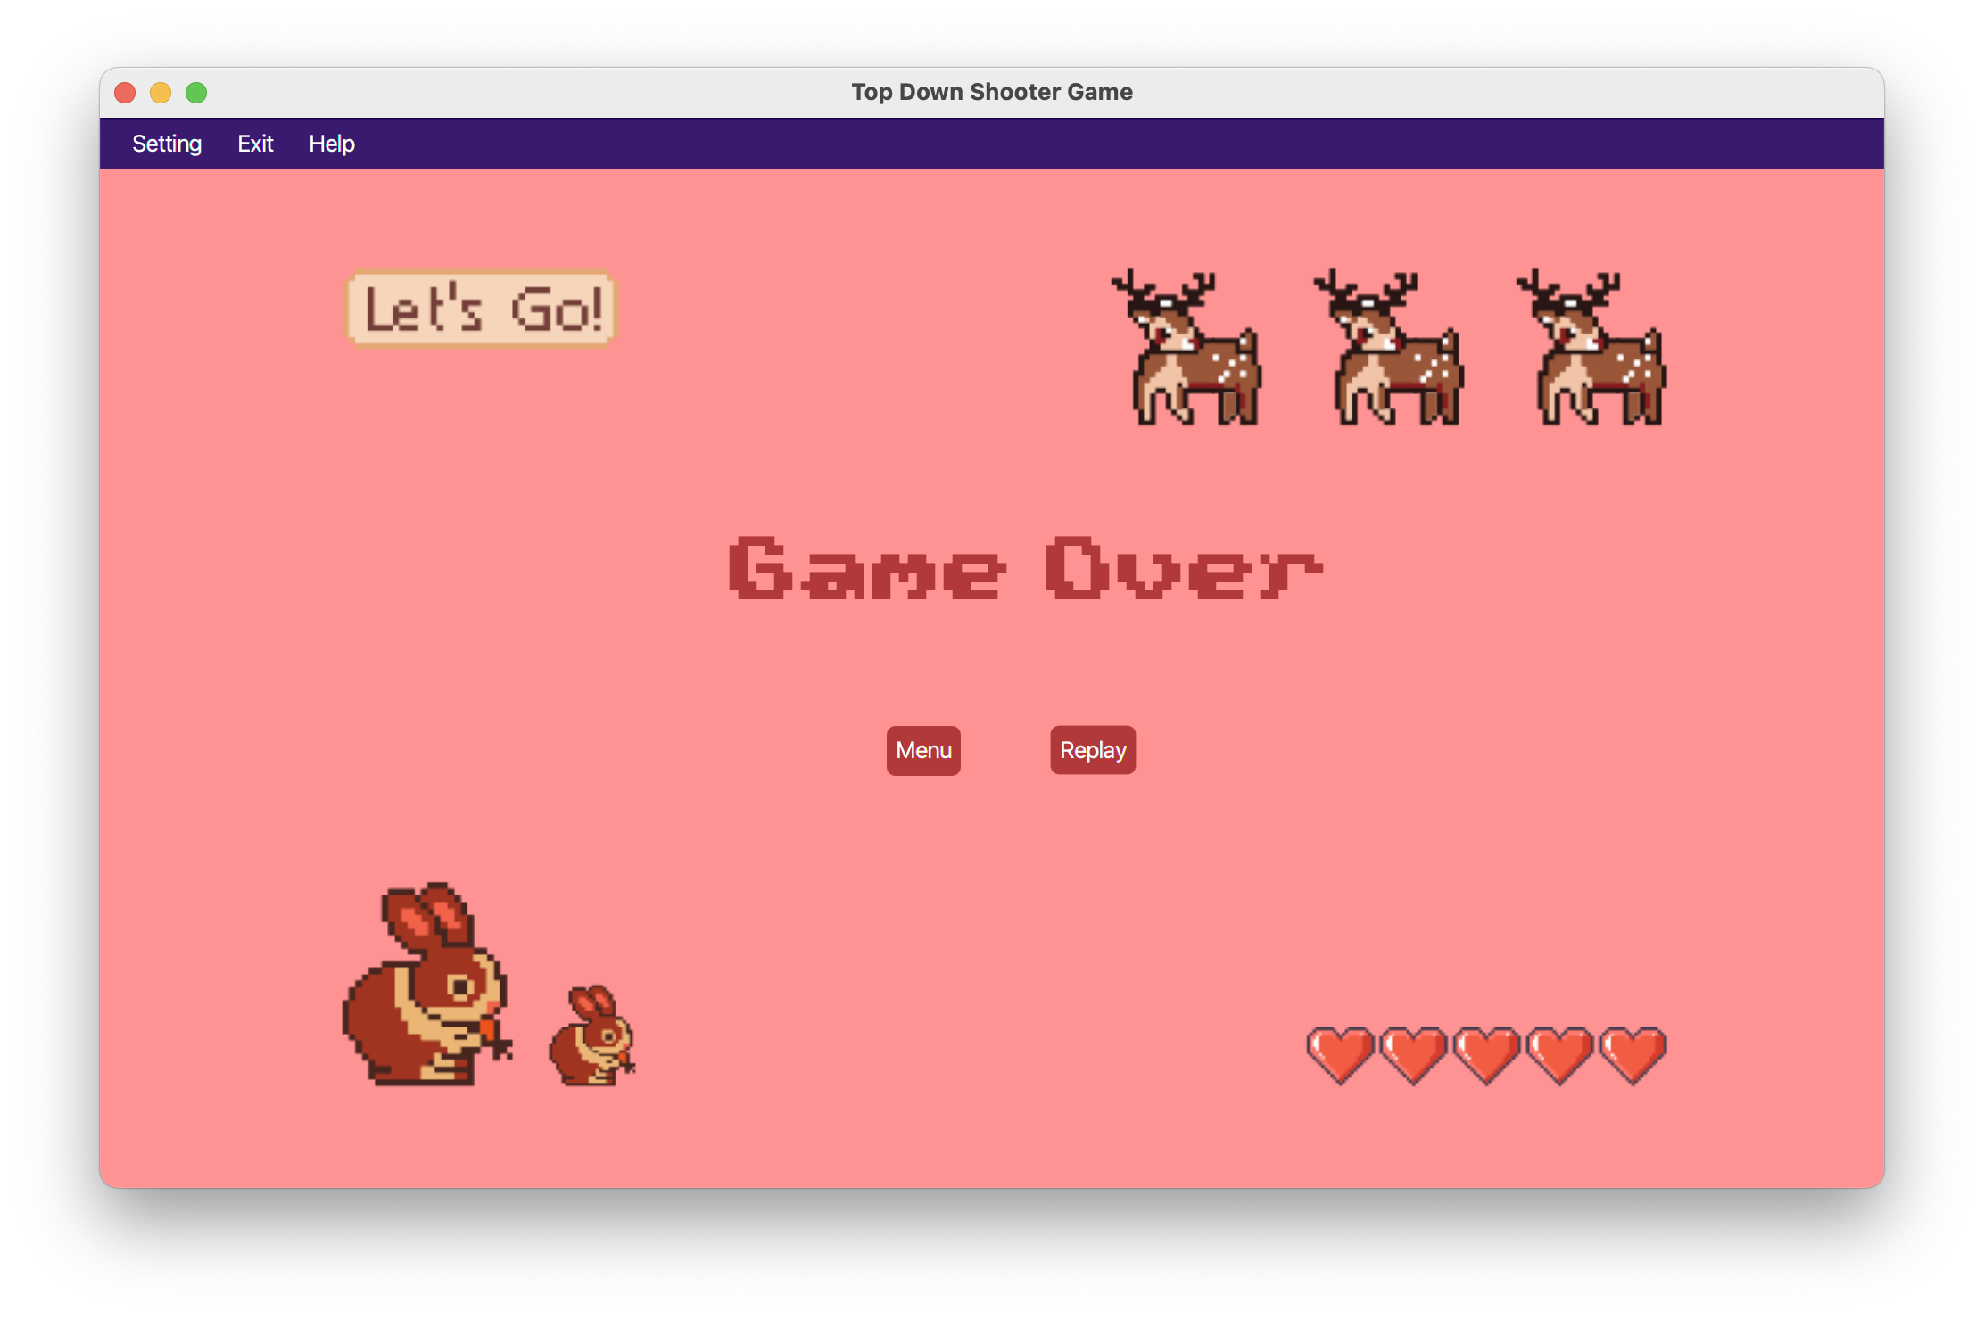

When the player health decrease until 0, the Game Over interface will pop out, the player are allow to replay the game or back to the menu page. This action is handle by the **GameOverController** class.

## 3.2: User Navigation and Shooting (Mouse and Keyboard input)



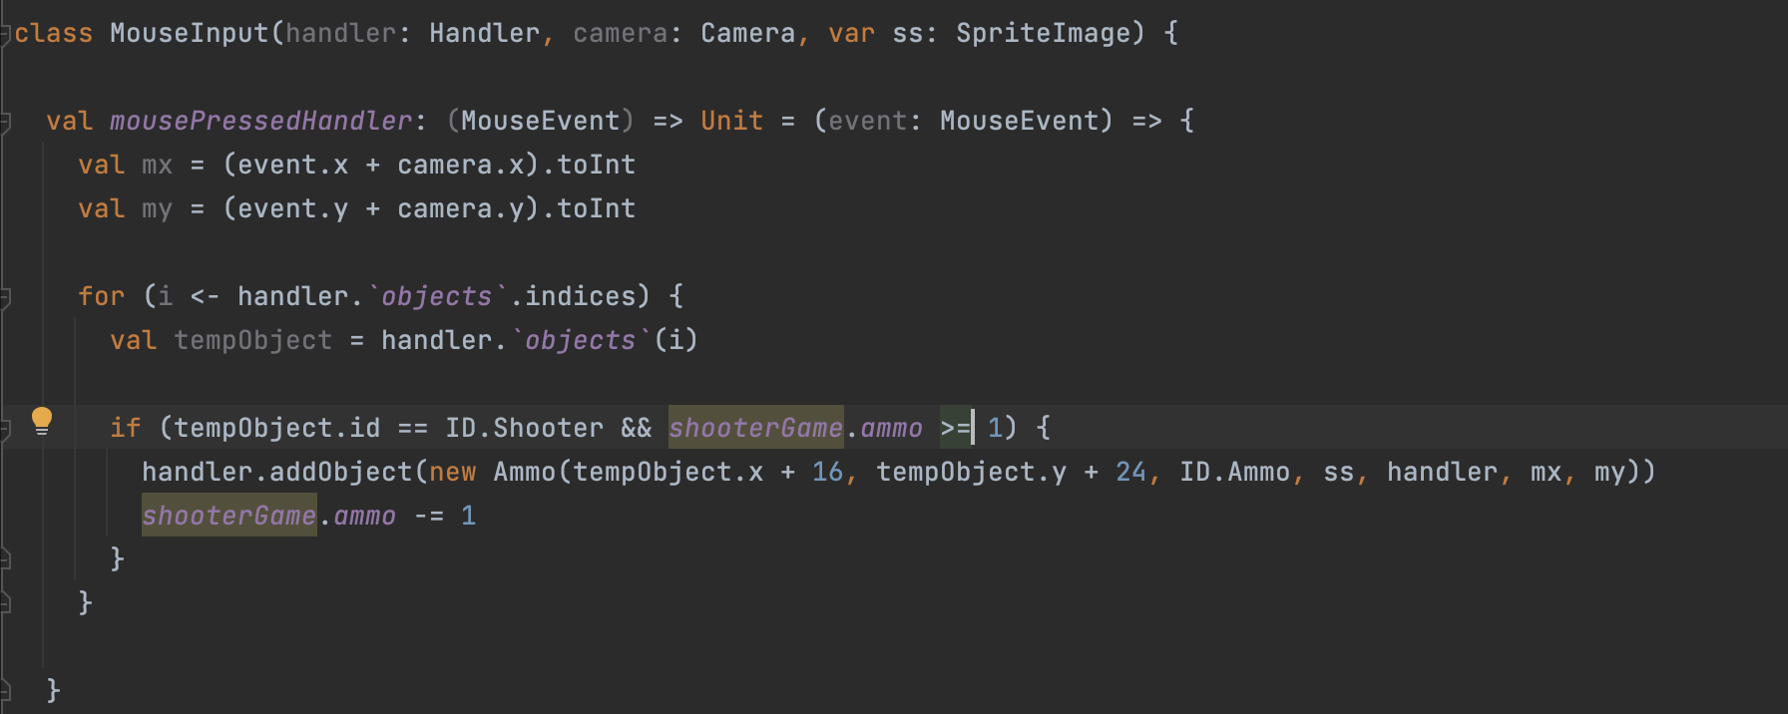

The **mousePressedHandler** function of the **MouseInput** class is in charge of handling mouse click events. The coordinates of the player's mouse click, as adjusted by the camera's position, are recorded as mx and my. The handler then searches the game objects for the player's shooter object and determines whether there is sufficient ammunition. If all of these criteria are satisfied, a fresh Ammo object is generated at the player's position and pointed in the direction of the mouse click coordinates. By doing this, the game effectively shoots in the direction of the mouse click.

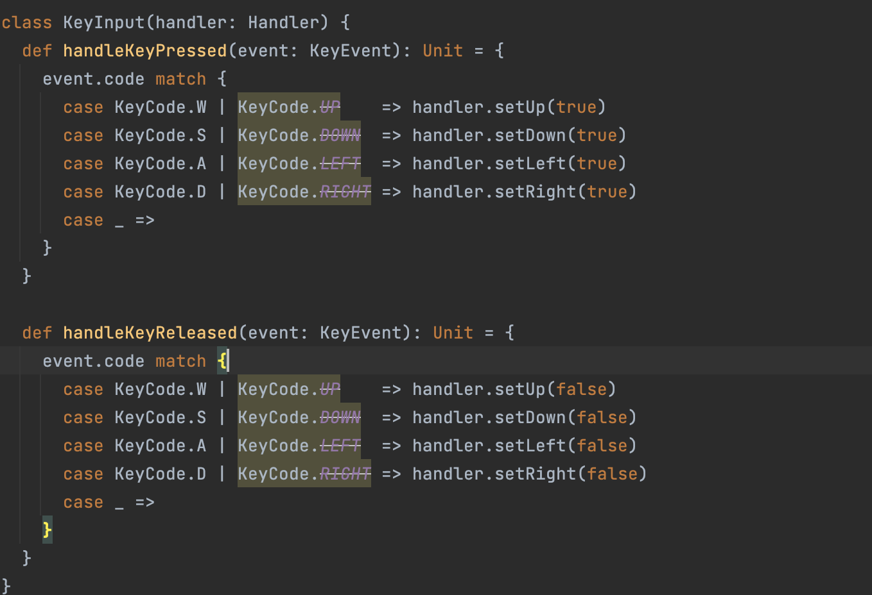

The **handleKeyPressed** and **handleKeyReleased** functions of the **KeyInput** class control the player's movement based on keyboard input. The handler's associated direction flag is set to true when a key is pushed (pressing "W" or "UP" sets **handler.setUp(true)**), for example, and is reset to false when the key is released. The player's position is then updated using these flags in the game's main loop, enabling movement in the direction indicated by the pushed keys.

## 3.3 Enemy Movement (Chasing Enemy and normal enemy)



Please refer to the source code if needed.

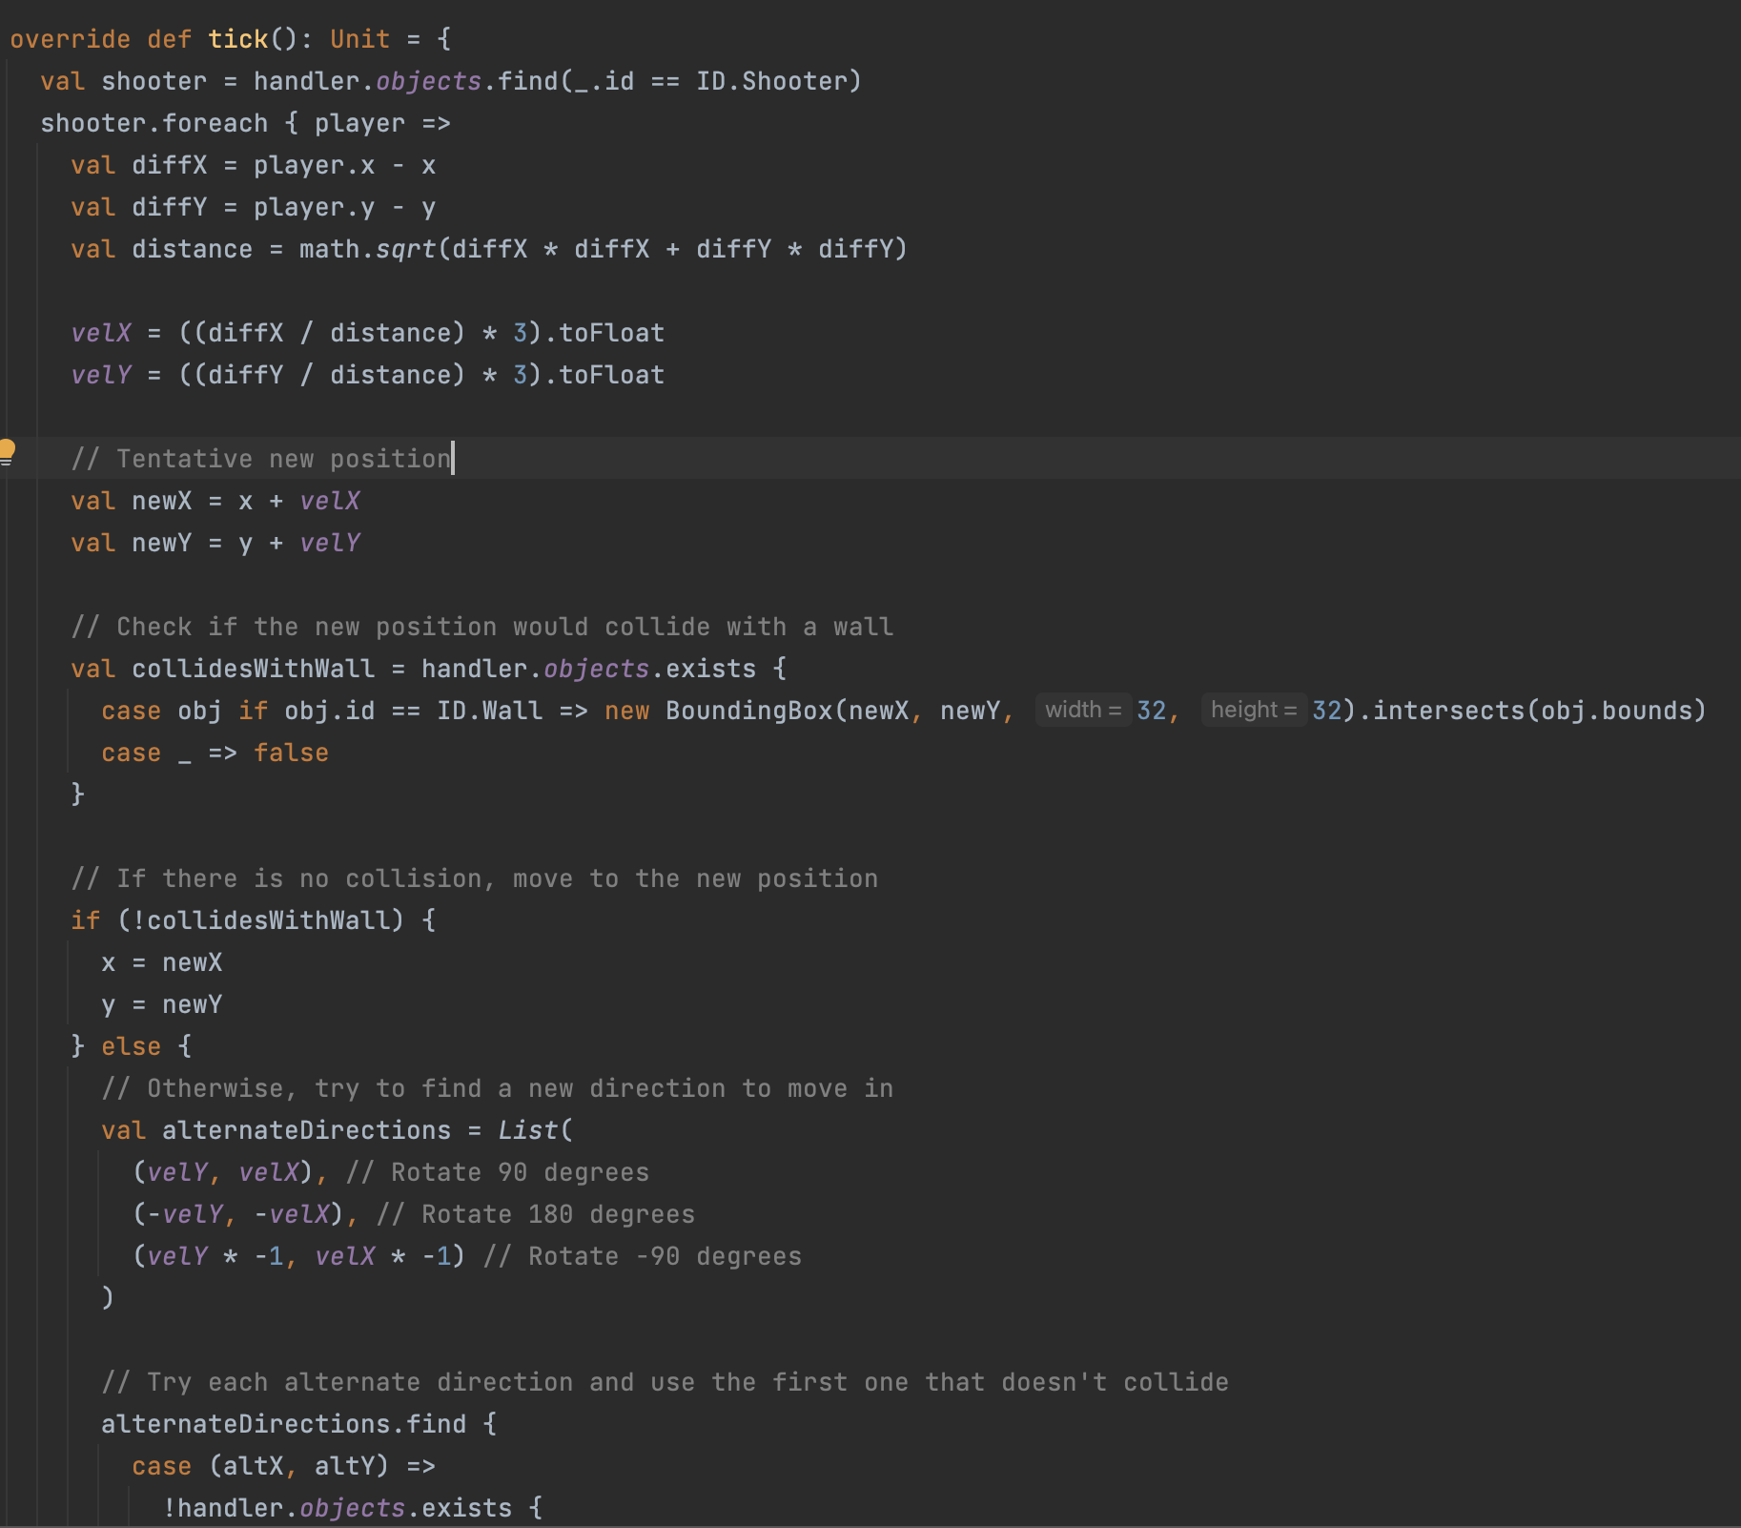

The **ChasingEnemy** class is made to stick with the shooter object that the player is using. The **tick** method first determines the player's shooter object before computing the x and y coordinate difference between the player and itself. After determining the distance, it adjusts its velocity **(velX and velY)** to move in the direction of the player. It determines whether moving might result in a collision with a wall before moving. If not, it repositions itself. It attempts other directions if there is a collision. The pursuing enemy's health (**hp**) is decreased if it hits an **ammo** object, and if the health reaches 0, it is eliminated from the game.

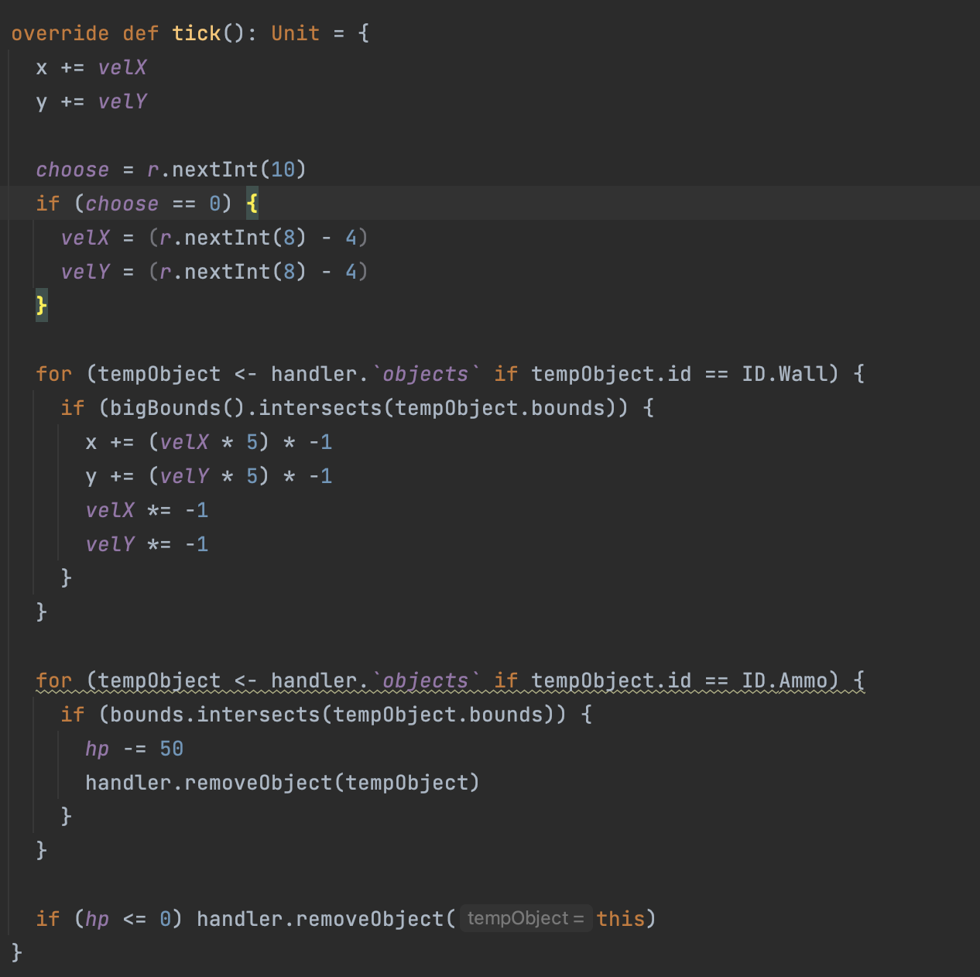

A normal enemy with unpredictable movement is represented by the enemy class. It selects a new velocity (**velX and velY**) at random within a range in its **tick** function, which causes the adversary to move slightly erratically. When an adversary hits a wall, it changes direction and retreats from the wall. Similar to the chasing enemy, the standard enemy's health (**hp**) is decreased whenever it collides with an **ammo** object, and if the health reaches 0, it is eliminated from the game.

## 3.4 Collision detection (Player collision between walls, enemy, and bonus)

Collision with wall:



The collision method identifies the intersection with any in-game object designated as a wall (ID.Wall) when the shooter collides with one. The position of the shooter is changed by reversing its velocity in both the x and y dimensions if its bounding box interacts with a wall's bounding box. The shooter essentially bounces back from the wall as a result of this.

Collision with enemy:



The shooter's health (hp) is reduced by one if they connect with a regular opponent (ID.opponent) or a chasing enemy (ID.ChasingEnemy). However, a period of invincibility is put in place to stop rapid health loss. After being hit, the shooter enters a temporary state of invincibility (invincibilityPeriod), during which time any subsequent collision with the enemy do not deplete the shooter's health. To control this period of invincibility, the last hit time (lastHitTime) is kept in memory.

Collision with bonus point:



When the shooter collides with a bonus point (ID.Bonus), there is a 1/3 chance to increase the shooter's health by 1 (up to a maximum) and a 2/3 chance to increase the shooter's ammo count by 10. The bonus object is then removed from the game.

## 3.5 Collision detection (Enemy collision between walls, and Ammo (bullet)



Collision with the Ammo (Bullet):

When updating the enemy's state, the tick method looks for collisions with any in-game item designated as a wall (**ID.Wall**). The enemy's position is changed by reversing and amplifying its velocity in both the x and y directions if the enemy's extended bounding box (**bigBounds()**) connects with a wall's bounding box. The opponent is forced away from the wall and alters course as a result of this reaction.

Collision with Wall:

Also within the tick method, the enemy checks for collisions with bullets (identified as **ID.Ammo**). If the enemy's standard bounding box (**bounds**) intersects with a bullet's bounding box, the enemy's health (**hp**) is reduced by 50, and the bullet is removed from the game by calling **handler.removeObject(tempObject)**. If the enemy's health drops to 0 or below, the enemy itself is removed from the game.

## 3.6 Sprite Image

Figure 3.6.1:

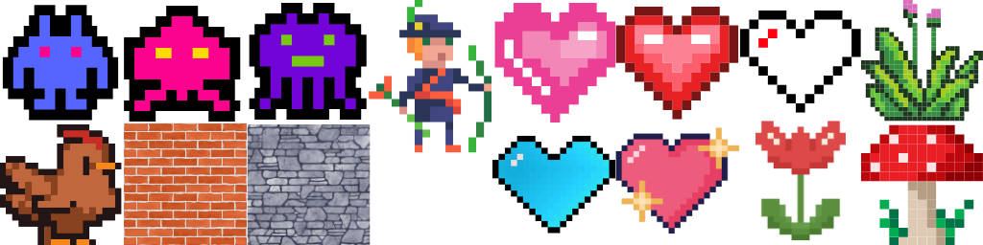

Sprite Image is essential in developing our Top Down Shooting Game. In 2D video games, sprites are frequently employed to illustrate people, things, or other visual components in the game world. In particular, a sprite image is the graphic depiction of a sprite.

Figure 3.6.1 shows the sprite image that used in our game, the image is generated using Canva, which aims to designed the game with the theme of pixelated environment.

**SpriteImage** Class:

In the **SpriteImage** class, it has a method called **grabImage** that allows you to extract individual sprites and is initialised with an image (likely a sprite sheet). A specific sprite is located and extracted from the sprite sheet using the column, row, width, and height parameters, and is then returned as a **WritableImage**. It determines the beginning coordinates of the sprite by multiplying the column and row by 32 and taking 32 out of the equation. By providing quick access to individual sprites from a bigger image, this class simplifies the process of organising and rendering various graphic elements within the game.

Example usage of **StriteImage** class:

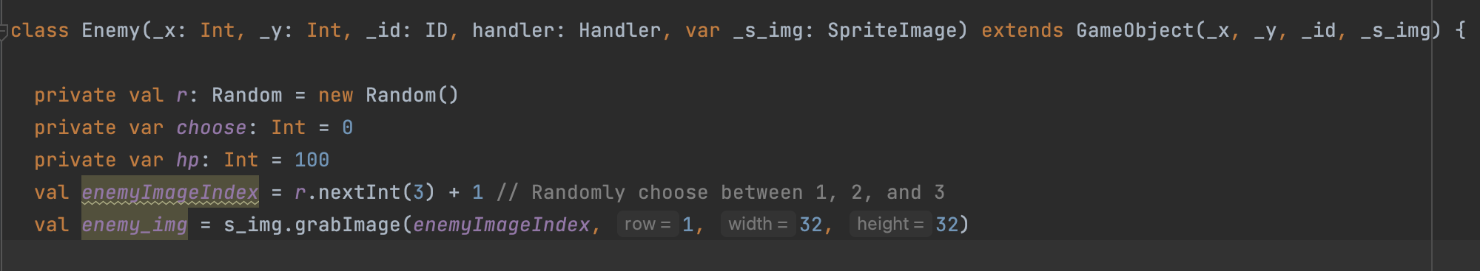

Using the **s_img.grabImage** method, the **enemyImageIndex** is randomly selected between 1 and 3 and the associated sprite picture is obtained. Choosing a random image from a pool of available ones enables diversity in the appearance of enemy.

# 4.0 Strengths and weaknesses

## 4.1 Strengths

The code's strength lies in its effective use of Object-Oriented Programming (OOP) principles, which contribute to a robust and organized structure. By employing encapsulation, the code is divided into modular classes, each with its specific responsibility, such as handling sprites, defining enemies, or managing user input. This ensures that related attributes and behaviours are grouped together, leading to more maintainable code and facilitating future enhancements. Inheritance also used in determine the game object, and the structure and attributes of the game object can be easily extends by new game object classes. This further reduce code redundancy and allow different implementation by overriding on the superclass method if necessary. The use of polymorphism could be inferred in the way classes like GameObject are extended by specific game objects like Enemy. Overall, the application of these OOP principles contributes to the code's clarity, maintainability, and extensibility, providing a strong foundation for further development.

## 4.2 Weaknesses

The weaknesses of the game lies between the respawns of the enemy, although the game have generated a lot enemy, however, when all the enemy disappear and killed, the game does not validated the ending of the game and will continue run the game. This can be solve by adding in new validation for the code. And achieve with similar concept as the game over prompting interface. We can achieve this easily since the code is well maintained and coded using object oriented principle. For example, in the **MainApp** class, we can define a **new functio**n called **showGameWinningScreen**, and in the **ShooterGame** class, we can provides logic in the tick function, which check when the number of enemy is equal to 0, then run the **showGameWinning** Screen and terminate the game loop.

Other than that, this is the first stage of the game implementation, it does not have any harder level game for the player to play, hence, in future implementation, we can increase the difficulty of the game by simply adding in more **Chasing Enemy** and **Normal Enemy** over time. This can be done in the game loop method, which able to keep track of the timing and generate the enemies based on the timing. The difficulty of the game can also increase by increase the damage of the enemy, or increase the hp (health) of the enemy, which will make the player use more ammo to kill the enemy.

If the difficulty level of the game is implemented, it is best to use the database to keep track of the player best performance. For example, we can keep track on the time used by the player to complete the game, or the number of level the player completed.

# 5.0 Personal Reflection

## 5.1 OOP Concept

The Scala mutable Buffer is used inside the handler class, to store the game object creates inside the game.

In Scala, a **mutable.Buffe**r is a collection representing a sequence of elements that can be altered after its creation. Unlike immutable sequences, which cannot be changed once defined, a **mutable.Buffer** allows elements to be appended, prepended, inserted at specific indices, removed, or updated. This flexibility allows us to frequent modified and updated any game objects that is destroyed/ created to the required sequence. However, this mutability can introduce complexities, especially in concurrent or parallel programming environments, where unintended modifications may lead to bugs or inconsistencies. Therefore, while **mutable.Buffer** provides a powerful and versatile tool for managing sequences, it should be used with caution in contexts where thread safety is a concern.

The Top Down Shooter game leverages Scala programming concepts to enhance code usability. For instance, there's no need to define separate setters and getters for every variable in the class. By utilizing constructor parameters or declaring variables with the var keyword, we can directly modify values, simplifying the code and making it more accessible.

**Composition:**

Composition refers to the practice of building complex objects by combining simpler ones. In the game, you can see composition in how different classes work together to create the game environment.

For example, the ShooterGame class composes different elements like GraphicsContext, KeyInput, MouseInput, Camera, SpritImage, ImageLoader and Handler. These elements are then used together to create the complete game environment, such as loading levels, rendering the game, and handling user input.

**Inheritance:**

Inheritance allows a class to inherit properties and behaviour from another class. In the Top Down Shooter game, this concept is visible in how different game objects are defined.

For instance, the ChasingEnemy, Enemy, and Shooter classes all extend the GameObject class. This means they inherit common properties and behavior defined in the GameObject class, such as position, velocity, and rendering methods, while still allowing for customization and specialization.

**Aggregation:**

Aggregation refers to the practice of using one object inside another to represent a "has-a" relationship. It allows a class to use the functionality of another class without inheriting from it.

In the game, aggregation can be seen in how the Controller class aggregates methods of other classes like MainApp. These methods are used within the Controller class to call upon the method once the button is triggered from the user view.

**Polymorphism:**Polymorphism allows objects of different types to be treated as objects of a common type. This concept is particularly powerful in creating flexible and reusable code.

In the Top Down Shooter game, polymorphism is demonstrated by the usage of the **GameObject** class and its subclasses. Methods like **tick()** and **render()** are defined in the **GameObject** class and then overridden by its subclasses like **ChasingEnemy**, Enemy, and Shooter. This allows different types of game objects to be handled uniformly within the game loop, even though their behaviours differ.

By implementing these concepts, the code for the Top Down Shooter game becomes more modular, reusable, and maintainable. It allows for easier modification and expansion, enabling the creation of more complex game features and behaviours.

## 5.2 Challenges

Developing the Top Down Shooter game presented numerous challenges, particularly in adhering to good Object-Oriented Programming (OOP) practices. Initially, the code was riddled with redundancies, following a more sequential pattern that lacked reusability. This redundancy not only increased complexity but also made debugging more difficult, as changes to one class necessitated changes to all similar code segments. This lack of modularity and encapsulation was addressed through code refactoring, a process that enhanced the code's readability, maintainability, and overall quality.

Code refactoring was not just a one-time fix but an ongoing effort to align the code with best practices. It enabled the transformation of a previously rigid and repetitive codebase into a more dynamic and adaptable structure. The refactored code leveraged inheritance, polymorphism, and composition, thus aligning more closely with OOP principles. These changes not only made the code easier to understand but also simplified future development, allowing for more seamless integration of new features.

Another significant challenge was the adaptation to a new programming language, Scala. Even though it was a subject of study throughout the semester, fully utilizing its features and idioms in a complex game development project required a steeper learning curve. There were instances where external sources had to be consulted, including online resources and discussions with lecturers, to gain a deeper understanding of specific language features and how they could be best applied in the game's context.

Other than that, the design challenge have been a difficult one. Since all the interface and background are owned design using Canva. More time are needed for the game development. Additional trial and errors are necessary to test if the background image match the colour of other element present on the page, such as the colour of the font and the colour of menu bar item. To ensure have good representation of the interface, a fit size of background images also needed.

The development process was a journey filled with obstacles and learning opportunities. It demanded a flexible approach to coding, a willingness to embrace new techniques and tools, and a commitment to continual improvement. By recognizing and overcoming these challenges, the project not only resulted in a functional and engaging game but also contributed to a richer understanding of software development principles and practices.

# 6.0 Conclusion

The development of the Top Down Shooter game using Scala and Object-Oriented Programming (OOP) principles presented a multifaceted project that encapsulated various concepts, challenges, and innovations. By leveraging essential OOP concepts such as inheritance, polymorphism, composition, and encapsulation, the project managed to create a structured and maintainable codebase. The application of the Model-View-Controller (MVC) pattern further reinforced this structure, making the system more modular and easier to manage.

Throughout the development process, challenges such as performance optimization, cross-platform compatibility, design considerations, and adapting to a new programming language were faced. These challenges were met with a concerted effort in code refactoring, continuous learning, and a creative approach to problem-solving.

The project also showcased the power of modern programming techniques and the flexibility of Scala, which facilitated the creation of an engaging and user-friendly gaming experience. The game's design, including the use of sprite images, collision detection, enemy movement, and user navigation, demonstrated a comprehensive understanding of game development concepts.

Despite certain weaknesses identified in the game, such as issues with enemy respawn and the lack of difficulty levels, the foundation laid through robust coding practices offers ample opportunity for future enhancements and refinements.

In conclusion, the Top Down Shooter game project is a testament to the potential of OOP and the versatility of Scala in building complex applications. It serves as a valuable learning experience, highlighting the importance of good coding practices, the effective use of design patterns, and the ability to adapt and innovate in the face of challenges. The success of this project emphasizes the ongoing relevance of OOP principles in modern software development and showcases the creative possibilities that emerge when technology and imagination align.

# 7.0 References

1. Dr Chin addressAppG1
2. Collision Detection: <https://youtu.be/oPzPpUcDiYY>
3. Reference from JavaFX collision detection: <https://youtu.be/BTDcR4smi5A>
4. Reference from JavaFX shooter: <https://youtu.be/YdVTyWDHhWM>
5. Reference from Java shooter: <https://youtu.be/Ny_YHoTYcxo>